Digital Pre Distortion
Power amplifiers, which are inherently nonlinear systems, are essential components in a communication system. The nonlinearity causes in-band distortion and a spectral regrowth, which leads to interference and violations of the out-of-band emission requirements. The use of different transmission formats, such as wideband code division multiple access and orthogonal frequency division multiplexing, which are known to have high peak to average power ratios, increases the risk to use the power amplifier in input voltages which are far from its saturation point, which leads to the distortions mentioned above. As a result, power amplifier linearization is essential.
Digital pre distortion is one of the most effective techniques of power amplifier linearization. According to this technique, a digital component, as known as a predistorter, is entered between input signal and the power amplifier, and creates an expanding nonlinearity which is complementary to the nonlinearity of the power amplifier. Ideally, with this predistorter, the power amplifier can be used with voltages that are not in its saturation range, while still maintaining a good linearity.
This instantaneous nonlinearity is usually characterized by the AM/AM and AM/PM power amplifier responses. AM/AM is the relation between the amplitude of the input signal and the amplitude of the output signal, which ideally should be linear, but as a result of the distortion is usually nonlinear. AM/PM is the relation between the amplitude of the input signal and the phase difference between the input signal and the output signal. Ideally the phase difference should be zero but as a result of the distortion is changing as function of input signal’s amplitude.
Many times, power amplifiers exhibit memory effects, which means that the current output of the power amplifier depends not only on the current input, but also on past input values, and makes the power amplifier a nonlinear system with memory. Therefore, digital predistorter should also have memory structures.
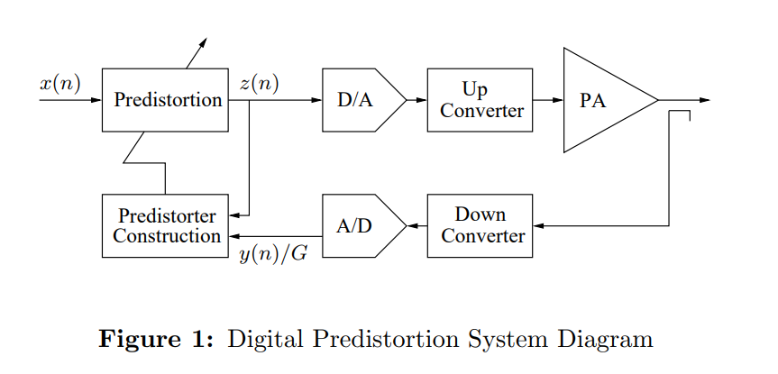
“Digital Predistortion of Power Amplifiers for Wireless Applications “, Lei Ding
AM/AM and AM/PM
AM/AM and AM/PM distortions in power amplifiers are distortions occurring when the power amplifier system is nonlinear. Due to its nonlinearity, the power amplifier can create harmonics of the fundamental frequency of the input signal. Moreover, it can get a signal constructed of multiple frequency components, for example $f_{1},f_{2}$, and due to nonlinearity, create new frequency components, in the form of $nf_{1}±mf_{2}$.
In narrowband systems, intermodulation distortion at distant frequencies such as $2f_{1}+f_{2}$ or $f_{1}-f_{2}$ in the above example can be ignored by filters. In contrast, frequencies which are close to original frequencies, such as $2f_{1}-f_{2}$ or $2f_{2}-f_{1}$ in the above example, cannot be ignored by filters. This kind of distortion is called “n-th order distortion”, while n is the power of the exponent of the nonlinear system which caused the creation of the frequency component.
AM/AM distortion is when output’s amplitude is not a linear function of the input signal amplitude, as wanted in a power amplifier. This nonlinearity can be represented in a graph, where the output amplitude is shown vs input signal amplitude.
AM/PM distortion is when the phase difference between output and input signal depends on input signal amplitude, which is unwanted in a power amplifier. This dependence can be represented in a graph, where the phase difference between input and output is shown vs input signal amplitude.
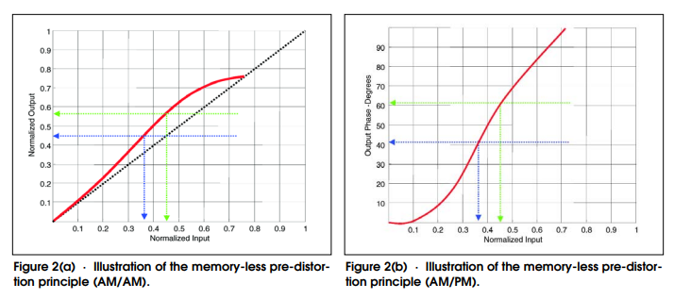
Figure 2 – AM/AM and AM/PM as shown in: “Fundamentals of Power Amplifier Linearization Using Digital Pre-Distortion”, M.K.Nezami

Modeling power amplifier using Volterra series
Volterra series can be used for modeling systems with both non-linearities and memory effects, and it is ideal for modelling the output of power amplifiers. The general form of the discrete Volterra series is given by:
$$y\left(n\right)= \sum_{k=1}^{K}{\sum_{m_{1}}^{M-1}{…}\sum_{m_{k}}^{M-1}{h_{k}(m_{1},…,m_{k})\prod_{l=1}^{k}{x(n-m_{l})}}}$$
where $y(n)$ is the output sample, $x(n)$ is the input sample, K is the order of non-linearity of the system, M is the order of memory of the system, and $h_{k}(m_{1},…,m_{k})$ is a coefficient with set values as a function of k and $m_{1}…m_{k}$
The extensive number of coefficients related with every combination of input sample and delayed input sample combinations within the bounds specified makes it possible to model large scale of nonlinear systems with memory effects. It is able to model systems with both large non-linearities and drastic memory effects, and by raising the nonlinear and memory orders, K and M, the model can become more accurate. However, the complexity in calculating the coefficients increases dramatically as either K or M is increased. As a result, many simplifications of the full Volterra model, with less coefficients, have been devised. One of these is the Memory Polynomial model, which is given by:
$$y_{MP}\left(n\right)= \sum_{k=0}^{K-1}{\sum_{m=0}^{M-1}{h_{km}x\left(n-m\right){\left|x\left(n-m\right)\right|}^{k}}}$$
where $y_{MP}(n)$ is the output sample, $x(n)$ is the input sample, K is the order of non-linearity of the system, M is the order of memory of the system, and $h_{KM}$ is a coefficient with set values as a function of 𝑘 and 𝑚. This model can be represented efficiently in matrix form as:
$$y=Xθ_{MP}$$
$$\left[\begin{matrix}y(n) \\ ⋮ \\ y(n+N)\end{matrix}\right]=\left[\begin{matrix}x(n) & ⋯ & x\left(n-m\right){\left|x\left(n-m\right)\right|}^{k} \\ ⋮ & ⋱ & ⋮ \\ x(n+N) & ⋯ & x\left(n+N-m\right){\left|x\left(n+N-m\right)\right|}^{k}\end{matrix}\right]\left[\begin{matrix}h_{00} \\ ⋮ \\ h_{km}\end{matrix}\right]$$
where 𝒚 is the outputs array of the MP model, $θ_{MP}$ is the coefficients array , and 𝑿 is an matrix containing the signal, delayed values of the signal, and their powers, which required for calculating the output. This means that the matrix can be created given only the input sample array and the order of non-linearity and memory order of the MP model to be used. The coefficient array $θ_{MP}$ contains the unknown coefficients $h_{km}$ that represents the power amplifier
כעת צריך לבוא הסבר על שערוך הפרמטרים, שמופיע במאמר המצורף.
זה השלב הבא בפרוייקט לכן לא סיכמתי על זה עדיין.

